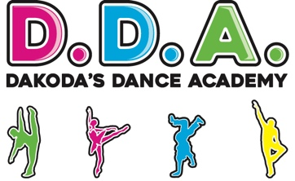

DDA modern slavery and human trafficking statement
Here are the steps DDA has taken and continues to take to understand and minimise the potential risk of modern slavery in its business and supply chains.
This statement is published in line with section 54(1) of the Modern Slavery Act 2015.

Our commitment to the principles of the Modern Slavery Act 2015
DDA is committed to the principles of the Modern Slavery Act 2015 and the abolition of modern slavery and human trafficking.
As an equal opportunities employer, we're committed to creating and ensuring a non-discriminatory and respectful working environment for our staff. We want all our staff to feel confident that they can expose wrongdoing without any risk to themselves.
Our recruitment and people management processes are designed to ensure that all prospective employees are legally entitled to work in the UK and to safeguard employees from any abuse or coercion.
We do not enter into business with any organisation, in the UK or abroad, which knowingly supports or is found to be involved in slavery, servitude and forced or compulsory labour.

Our supply chain
Due to the nature of our business, we assess ourselves to have a low risk of modern slavery in our business and supply chains.
We do not sell items and have agood interview and vetting process.

Our policies in relation to the Modern Slavery Act 2015
All our policies are available to all staff through the DDA website

Embedding the principles
We will continue to embed the principles through:
- providing awareness training to staff on the Modern Slavery Act 2015 and informing them of the appropriate action to take if they suspect a case of slavery or human trafficking
- ensuring staff involved in procurement activity are aware of and follow modern slavery procurement guidance on GOV.UK
- ensuring that consideration of the modern slavery risks and prevention are added to DDA’s policy review process as an employer and procurer of goods and services
- making sure DDA procurement strategies and contract terms and conditions include references to modern slavery and human trafficking
- continuing to take action to embed a zero tolerance policy towards modern slavery
- ensuring that staff involved in buying or procurement and the recruitment and deployment of workers receive training on modern slavery and ethical employment practices
This statement has been approved by Robert Myers, for the year ending 31 Jan 2025.

